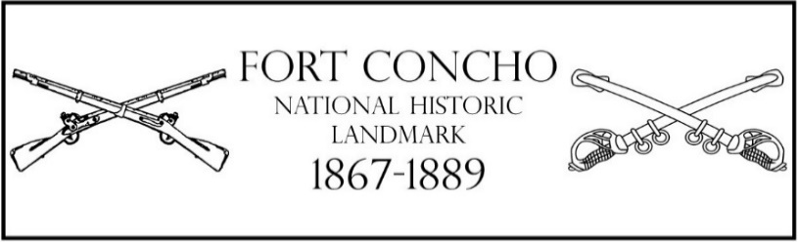

Summer Embroidery Program
Adult: June 26th 2021 (9AM-12PM)
Children: June 29th or July 6th 2021 (8AM-12PM)
Registration and Release form
Information:
Fort Concho Summer Embroidery Program is designed to teach participants embroidery skills they can use for the rest of their lives. While they embroider, they also get to know the other participants. Fort Concho hopes to teach the participants the basics of embroidery, including threading a needle, how to assemble fabric in a hoop, the running stitch, and the back stitch. If there is additional time, participants will learn more complex stitches. Participants will be allowed to keep their hoop, finished products, and needle upon completing the program.
Age Guidelines: The children’s program is designed for children who have completed grades 3rd through 12th. The adult’s program is designed for anyone ages 18 and up willing to learn.
Hours: the children should be dropped off between 8 and 815AM. Please do not drop your child off before as you will need to sign your child in. Sign out will take place from 12 and 1215 PM. Please pick up your child at the correct time as staff cannot watch your child after 1215PM.
Location: This program will take place at Officers’ Quarters 9, at Fort Concho. The building is located at 217 E Ave. D, next to the schoolhouse/chapel.
Cost of program: The program costs $10 per participant. The cost includes materials used for the program. The total will be due when the registration form is submitted. There is limited space for this program. We require the payment in order to confirm their space.
Medical needs/Allergies: Fort Concho staff is not permitted to administer medication of any kind to program participants. In the event of a medical emergency, Fort Concho staff will administer first aid, CPR, and rescue in the best interest of the child. Parents will be contacted if care is administered.
Behavior Management/ Discipline Policy: Fort Concho Staff will create a safe, fun environment for participants in the program. The staff will use positive behavior management; any behavior that is distracting and takes away from the program will be corrected in a professional and positive manner. Parents may be contacted if the problematic behavior continues.
Snacks/Water: The hot Texas sun can be unforgiving and we want the children to be safe. Please have the children bring only water in a non-glass bottle with a resealable lid. If children would like to bring a snack, there is no issue. We recommend it be nothing sticky because it can make working with a needle complicated.
Registration: (If over the age of eighteen, please leave parent spaces blank.)
Participants’ name: ___________________________________________________________________
Grade completed (as of May 2020) ________ D.O.B.: ________________________________________
Address: ____________________________________________________________________________
Parents/Guardians Name: ______________________________________________________________
Phone#:___________________________ Work Place: _______________________________________
W. Phone#:________________________

Camper Check-Out: At the end of the program, your child must be signed out by an authorized adult; if none are listed in the space below the child will be released only to the parent/guardian who signs this form: ______________________________________________________________________________________
By signing this registration form I also authorize the taking of pictures of my child for camp and Fort Concho promotion purposes. Signature of Parent/Guardian: ___________________________________
Health Information
In Case of emergency, notify: ___________________________________________________________
Relationship: _____________________________________ Phone: _____________________________
Other contact: ________________________________________________________________________
Allergies (including respiratory, food, and/or medication): ____________________________________ ____________________________________________________________________________________
Other Health concerns (frequent sickness, injury, surgery, and/or recent illness): ___________________
____________________________________________________________________________________
Behavioral or special concerns or considerations: ____________________________________________
____________________________________________________________________________________
Fort Concho staff is not permitted to administer medication to program participants. In the event of a medical emergency, Fort Concho staff will administer first aid, CPR, and rescue in the best interest of the child. Parents will be contacted if care is administered.

Waivers: (For participants under the age of eighteen)
By signing this form, I, as parent/guardian, permit Fort Concho National Historic Landmark to use pictures of my child(ren)as a program participant in promotional literature, videos, and the Fort Concho website. I understand my child(ren)’s name(s)will not be published.
Signature: ________________________________________________ Date: ____________________
Printed Name: _______________________________________________
Circle one: Parent / Guardian

