United States Cavalry Association Regional Competition
at
Fort Concho National Historic Landmark, San Angelo, Texas
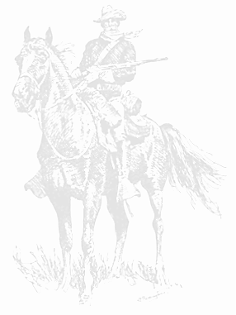
April 21-25, 2021
REGISTRATION

Name:Click here to enter text.
(as you want it in a name tag)

Address: Click here to enter text.

Phone: Click here to enter text. E-Mail Click here to enter text.

Unit or group representing: Click here to enter text.
Name of Horse: Click here to enter text.

General Registration Fee Number @ $85 = total
Schooling Horse Number @ $30 = total
USCA Special Membership in order to compete *** Number @ $25 = total
USCA Annual Membership Number @ $52 = total
Wednesday, April 21 Mounted/Dismounted Instruction YES☐ NO ☐
Extra meals for guests/non-competitors:
Thursday, April 22 Number @ $15 = $ total
Saturday, April 24 Number @ $20 = $ total
Total Due Total Due

General Registration Fee includes stabling facilities, on-site barracks spartan lodging as requested, Wednesday classes, breakfast and lunch on April 21-24, social/welcome event
on Wednesday, April 21; and evening supper on Thursday, April 22 and Awards Banquet on Saturday, April 24
All events, meals, and related activities will be held at Fort Concho National Historic Landmark.
*** You must be a USCA member or pay for a special membership in order to compete

DEADLINE IS APRIL 1, 2021

Payment may be made by check to Fort Concho Foundation and mailed to 630 South Oakes, San Angelo, Texas 76903;
for credit card sales call Fort Concho at (325) 481-2646.

